NetApp ONTAP Cloud with SQL Server on Azure
Quick Start Reference Deployment
Conditions and Terms of Use
This course package is proprietary and confidential. Duplicating, reselling and/or distribution of course materials in their entirety or in part is not permitted without the expressed prior written consent of Spektra Systems, LLC.
Contents
NetApp ONTAP Cloud with SQL Server on Azure 1
Overview 2
Costs and Licenses 2
Architecture 2
Prerequisites 3
Deployment Steps 3
Step 1. Creating an Active Directory Application 3
Step 2. Creating an Application Key. 7
Step 3. Assigning the Cloud Manager role to AD application 9
Step 4. Enable Programmatic Deployment 11
Step 5. Launch the Quick start template. 15
Deployment Time 15
Cleaning Up 15
Removing the ONTAP Cloud System using GUI 15
Deleting the Resource Groups from the Azure Portal 17
Security 19
Network Security Groups 19
Operating System Security 20
Identity and Access Management(IAM) 20
Troubleshooting 20
Support 20

Overview
This Quick Start reference deployment guide provides step-by-step instructions for deploying an environment with NetApp ONTAP Cloud and Microsoft SQL Server on Azure.
NetApp data storage systems are used by enterprises that require complete control, efficiency, durability, and resiliency of their data. NetApp ONTAP Cloud is a software-only version of Data ONTAP, which is the data management operating system from NetApp that is used on physical NetApp storage appliances.
The features of ONTAP Cloud include:
- Storage efficiencies that enable you to use less underlying storage capacity for your data needs
- Instant backup and recovery for data of all sizes
- Space-efficient, intuitive, bi-directional data transfer
- Instant, writable data clones that consume no additional storage capacity
- Ability to use multiple protocols (NFS, CIFS, and iSCSI) from the same storage system, at the same time

With ONTAP Cloud on Azure, you can spin up a new enterprise-class data management system in minutes on the cloud. This Quick Start automatically sets up a SQL Server 2014 – NetApp ONTAP Cloud with SQL Server on Azure.
Environment that receives its storage and enterprise-class data management capabilities from a NetApp ONTAP Cloud system running on AWS. The Quick Start uses NetAPP OnCommand Cloud Manager to deploy and configure ONTAP Cloud.

Costs and Licenses
This NetApp ONTAP Cloud is the PAYGO model and doesn't require the user to license it, it will be licensed automatically after the instance is launched first time and user will be charged hourly. Click here for pricing details.
To deploy the Quick start template, enable programmatic deployments in the azure subscription. Instructions are provided in the Deployment Steps section.
This Quick Start template includes configuration parameters that you can customize. Some of these settings, such as database size, will affect the cost of deployment.

Architecture
This template will deploy:
- Six storage accounts
- One Virtual Network with two subnets
- 2 Public IP’s, one for OnCommand Manager and one for the Jump VM
- One OnCommand Cloud Manager (BYOL) (for ONTAP Cloud)
- One Windows Server 2012 R2 VM.
- One SQL Server 2014 SP2 Enterprise on Windows Server 2012 R2 VM.
- One NetApp ONTAP Cloud VM

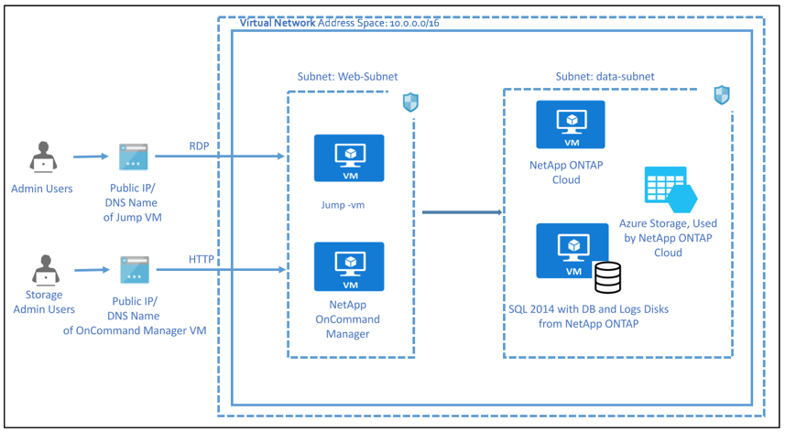

Prerequisites
Azure Subscription with specified payment method (NetApp ONTAP cloud is a market place product and requires payment method to be specified in Azure Subscription).
To deploy the Quick start template, programmatic deployments should be enables in the azure subscription. Instructions are provided in the Deployment Steps section.
An application key along with the application id is required for the deployment of this template. Instructions are provided in the Deployments Steps Section.

Deployment Steps

Step 1. Creating an Active Directory Application
- In the Azure Portal go to the Active Directory and click on App registrations.

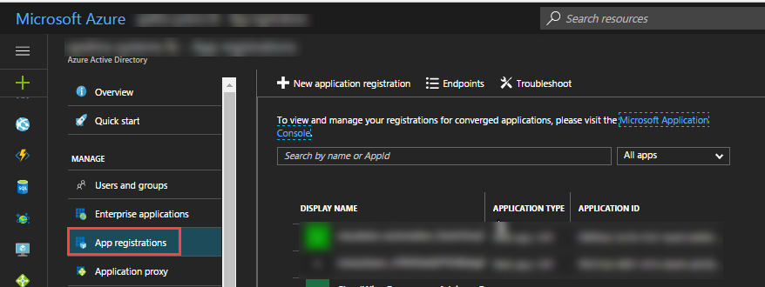

- Click on +New application registration
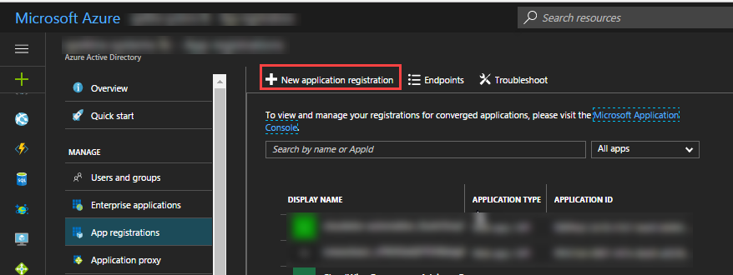

- Enter the following details:
Name: occm-api
Application Type: Web app/ API
Sign-on URL: http://sampleurl.com

- Click on Create.

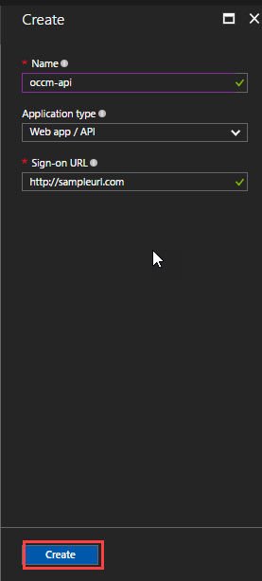

- The application will get created. After the application occm-api gets created, click on occm-api. Click on Required permissions.

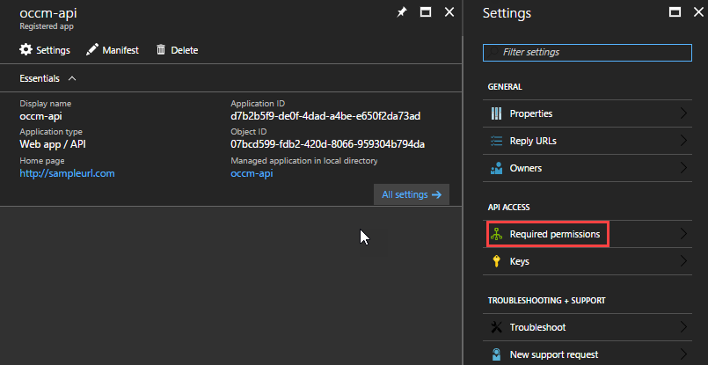

- Click +Add on Required permissions page. Click on Select an API. Select Windows Azure Service Management API.

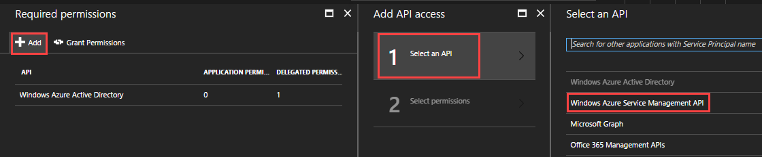

- Click on Select permissions and select Access Azure Service Management as organization users (preview). Click on Select.

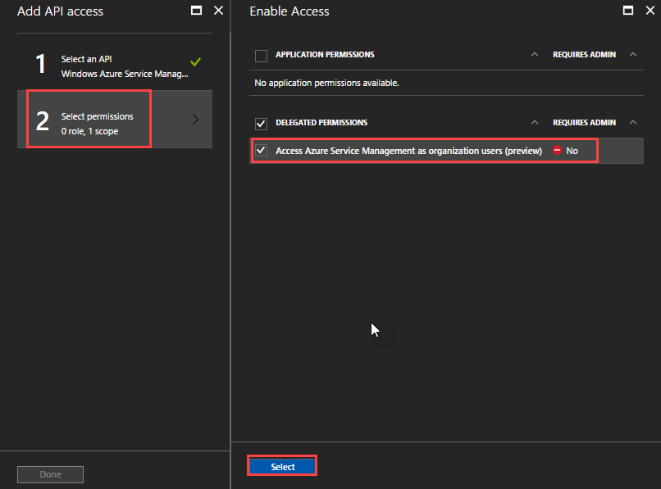

Step 2. Creating an Application Key.
- Click on Keys under the Settings page for your application id.
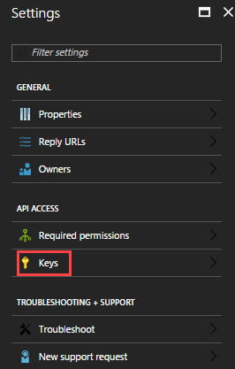

- Set an expiry and click on Save. The value of the key will be displayed after clicking on Save.

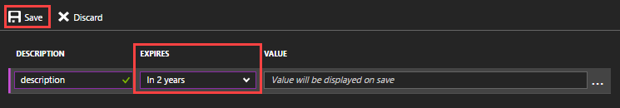
- Make sure to copy the Value as you won’t be able to retrieve after you leave the scope of the key creation. This value is used as application key for your Cloud Manager setup.

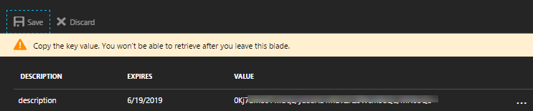

Step 3. Assigning the Cloud Manager role to AD application
- Click on More services and then click on Subscriptions.
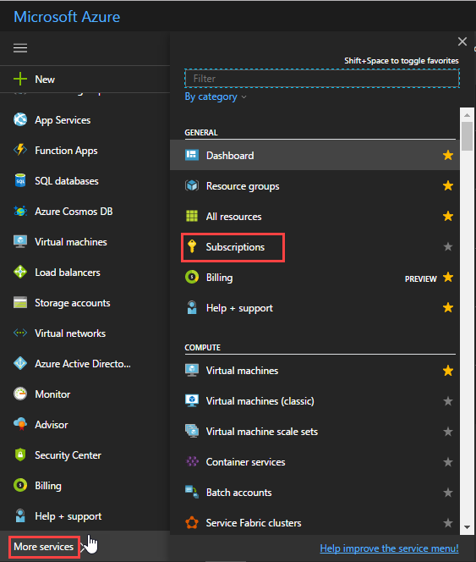

- Click on your Subscription and click Access Control(IAM)

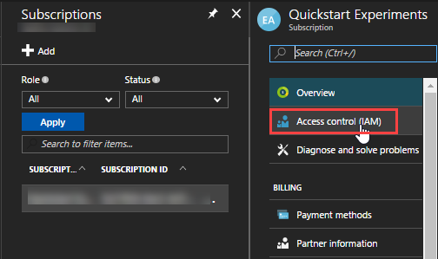

- After clicking Access Control(IAM) -> click Add (+)

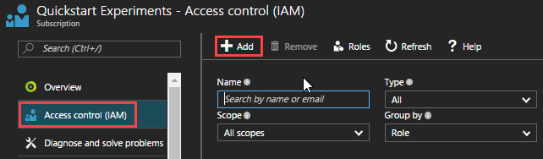

- After clicking on Add, enter the following details:
Role: Contributor
Select: occm-api
- Click on Save.
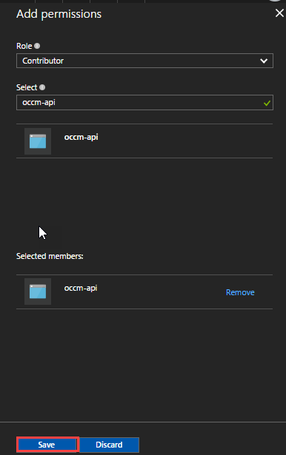

Step 4. Enable Programmatic Deployment
- Search for NetApp ONTAP Cloud in Marketplace.
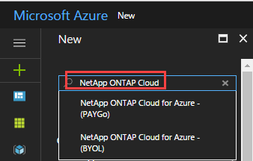
- Click on NetApp ONTAP Cloud for Azure – (PAYGo)
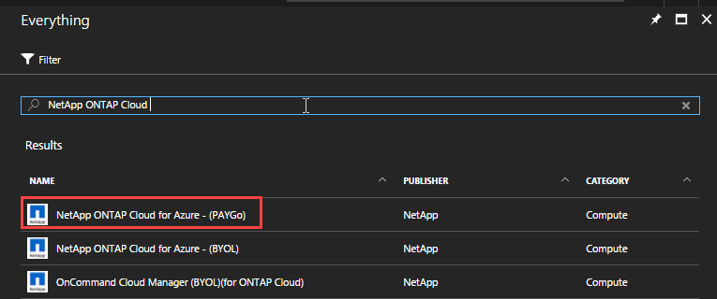

- Click on “Want to deploy programmatically? Get Started” link

- Toggle status from Disable to Enable for your subscription and click save.

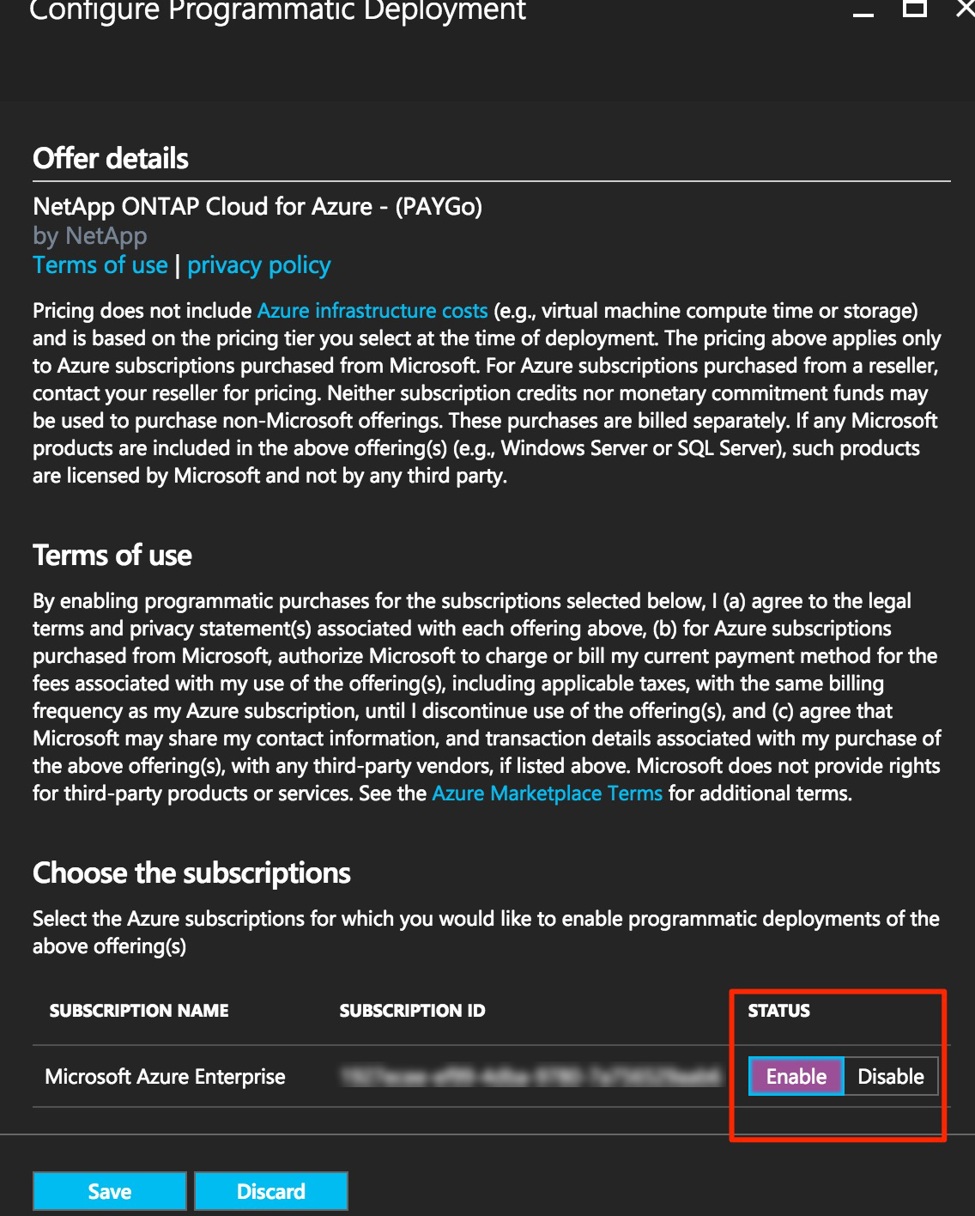

Step 5. Launch the Quick start template.
- Navigate to https://github.com/SpektraSystems/NetAppAzureQuickstart/tree/master.
- Launch the Template by click on Deploy to Azure button.
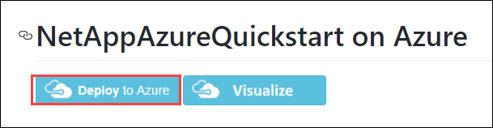

- Fill in all the required parameter values. Accept the terms and condition and click on Purchase.

Deployment Time
The deployment takes about 1 hour.

Cleaning Up
When you complete your work with ONTAP Cloud on Azure, you can clean up your account. Please follow the steps to clean up.

Removing the ONTAP Cloud System using GUI
- Go to the resource group in which the template is deployed.
- In the resource group click on oncommand-cloudmanager-pip.
- Copy the DNS name and paste it on any browser.
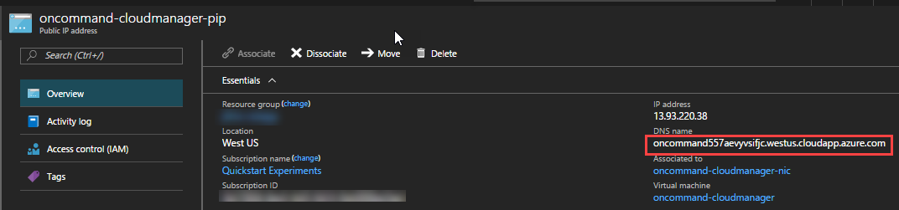

- Enter the Email ID and Password and click on Log In.

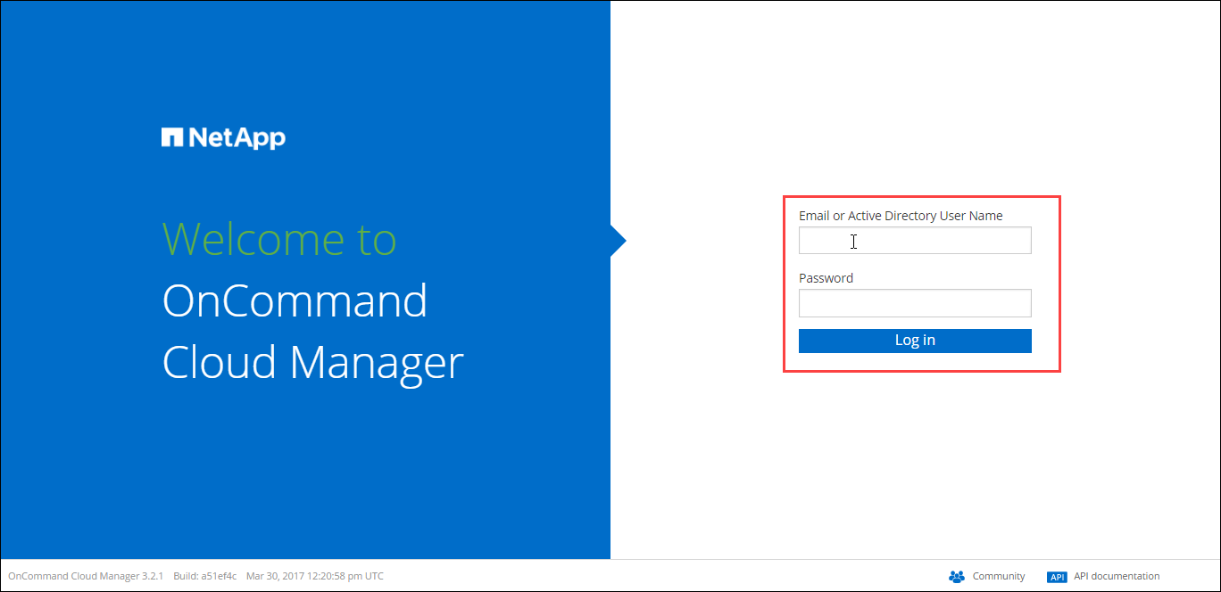

- Double click on the ONTAP environment that was created using the template.
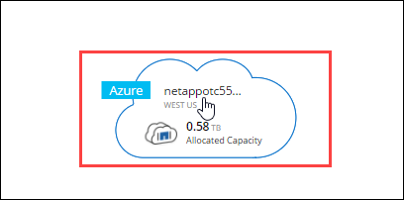

- From the three-bar icon in the upper-right corner of the screen, choose the option to Delete the ONTAP Cloud system.

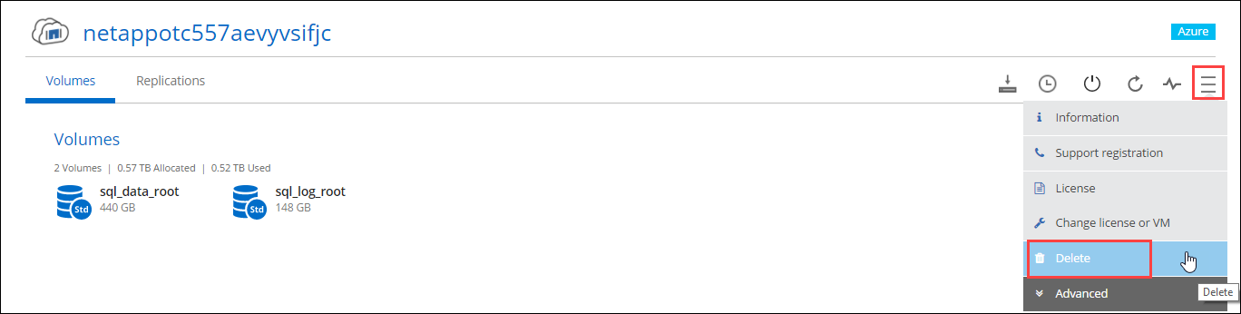

- Enter the working environment name in the space provided and click on Delete. Deleting would take some time to happen.

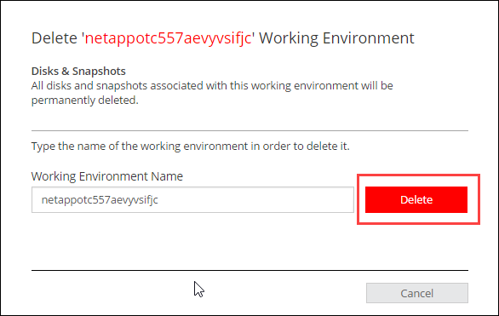

Deleting the Resource Groups from the Azure Portal
- In the portal click on Resource groups, and click on the resource group that have been deployed by the template.

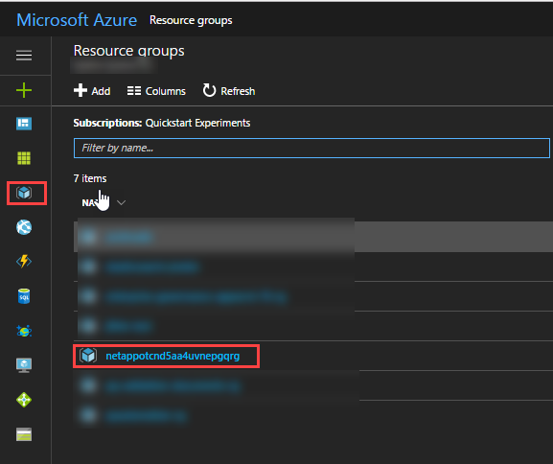

- Click on Delete button on the top.

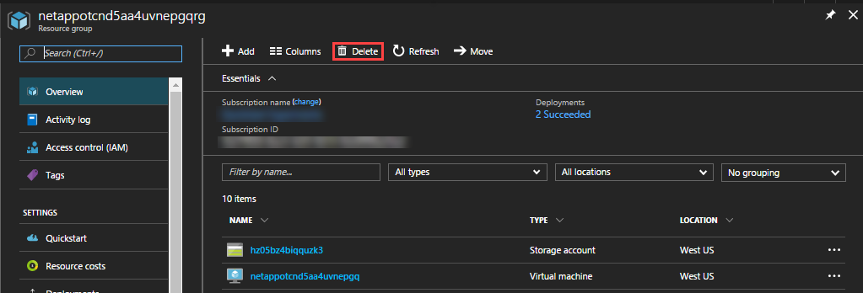

- Type the resource group name in the space provided and click on Delete.
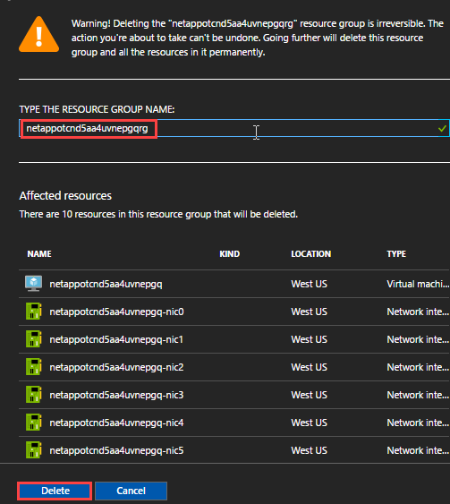

- Similarly delete the other resource group which was created using the template.

Security

Network Security Groups
The template creates Network Security Groups in which you can specify set of rules that can protect the deployments. A security group acts as a firewall that controls the traffic for one or more instances.
This template deploys two resource groups: data-nsg and web-nsg. Following rules are created by the template in the web-nsg.

Direction | Source | Destination | Service | Action
Inbound | 0.0.0.0/0 | 10.0.1.0/24 | HTTP(TCP/80) | Allow
Inbound | 0.0.0.0/0 | 10.0.1.0/24 | RDP(TCP/3389) | Allow

In addition to the rules that are being created, by default azure creates certain security rules that will monitor and block traffic. Please click on this link to know more in detail.

Operating System Security
The root user on ONTAP Cloud and Cloud Manager can be accessed only by using the password specified during the deployment process. Azure doesn’t store these passwords.
Operating system patches are your responsibility and should be performed on a periodic basis.

Identity and Access Management(IAM)
This solution leverages an IAM role with least privileged access while allowing access to the various functions needed by ONTAP Cloud. We recommend that you review the IAM role to further restrict access as needed once the deployment is up and running. We do not require or recommend storing secret keys, or access keys on the provisioned instances.

Troubleshooting

Support
For any support related questions, issues or customization requirements, please contact info@spektrasystems.com.

